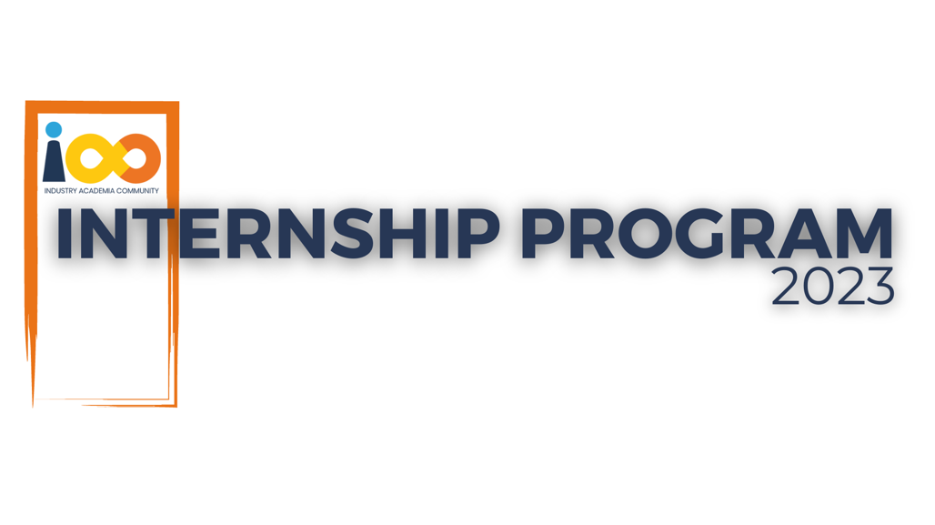

DEVELOPMENT LOG

WEB DEVELOPMENT   
  
COURSECONNECT

|  |  |  |  |
| --- | --- | --- | --- |
| **Created By:** | Nidhi Krishna Pednekar | **Approved By:** | <Domain Lead Name> |
| **Created On:** | 30-06-2024 | **Approved On:** | DD-MMM-YYYY |

|  |  |  |  |
| --- | --- | --- | --- |
| **DATE** | **ACTIVITY DESCRIPTION** | **ACHIEVEMENTS** | **REFLECTIONS** |
| 01-06-2024 | Started CourseConnect project | Set up project environment with Express.js, MySQL, and XAMPP | Began with defining project scope and requirements. |
| 04-06-2024 | Completed frontend layout design for home page | Integrated navigation bar with logo and basic page structure | Learned CSS techniques for layout and styling |
| 10-06-2024 | Implemented backend API endpoints for course search | Connected frontend search bar to backend API | Overcame challenges with API integration and routing. |
| 17-06-2024 | Conducted user testing for initial search functionality | Identified usability issues | Revised UI based on the testing results. |
| 19-06-2024 | Added filtering and sorting features to search results | Implemented dynamic filtering. | Explored JavaScript libraries for enhanced UI features |
| 27-06-2024 | Completed CourseConnect project | Finalized documentation and deployed project to production | Celebrated project completion and gathered feedback for future improvements. |